
Contents

Preface rili
Semiconductors 1.1-1.15
Goals and Objectives 1.1
1.1 Conduction in Solids 1.1
1.2 Doped Semiconductors 1.6
1.3 Hall Effect 1.10
Suntma1Y 1.13
Exercises 1.13
- Diodes and Applications 2.1-2.38
Goals and Objectives 2.1
  - Introduction 2.1
  - PN-Junction Diode 2.2
  - Zener Diode 2.10
  - Rectification 2.14
  - Power Supply Filters 2.23
  - Wave Shaping 2.24
  - Special-Purpose Diodes 2.28
Summary 2.34
Exercises 2.34
- Bipolar Junction Transistor (BJT) and Other Devices 3.1-3.36
Goals and Objectives 3.1
  - Introduction 3.1
  - BJT Construction and Operation 3.2
  - BJT Configurations and Characteristics 3.7
  - -Controlled Rectifier (SCR) 3.12
  - Unijunction Transistor (UJT) 3.18
  - Phototransistor 3.20
  - DC Biasing 3.21


Contents

4. Field Effect Transistors (FETs)
Goals and Objectives 4.1
4.1 Introduction 4.1
4.2 JFETs 4.2
4.3 Metal Oxide Semiconductor Field Effect Transistor (MOSFET) 4.12
4.4 FET Circuit Configurations 4.22
4.5 CMOS Circuits 4.27
4.6 FET Biasing 4.28 Sumnuuy 4.34
Exercises 4.34

5. Small-Signal Model of Transistors and Amplifiers
Goals and Objectives 5.1
5.1 Introduction 5.2
5.2 BJT Small-Signal Model 5.3
5.3 Hybrid Equivalent of BJT—Small-Signal Model 5.5
5.4 Small-Signal Model of FETs and Amplifiers 5.10
5.5 CE Amplifier 5.20
5.6 Effect of Source and Load Resistance 5.25
5.7 Frequency Response 5.26
5.8 Low-Frequency Response 5.28 5.9 High-Frequency Response 5.31 Summary 5.35
Exercises 5.35
- Op•Amp 6.1-6.26
Goals and Objectives 6.1
  - Introduction 6.1
  - Basic Op-Amp Circuits 6.5
  - Schmitt Trigger 6.17
  - Constant-Gain Multiplier 6.19 6.5 Basic Logarithmic Amplifier 6.19 Summary 6.22
Exercises 6.22
- Feedback Amplifiers and Oscillators 7.1-7,34
Goals and Objectives 7.1
  - Introduction 7.1

  - Types of Feedback 7.3
  - Gain Stability with Feedback 7.6
  - Large-signal Amplifiers 7.6
  - The Class B Amplifier 7.6
  - The Class AB Amplifier 7.9
  - Oscillators 7.11
  - Phase-shift Oscillator 7.13
  - Wien Bridge Oscillator 7.15
  - Tuned Oscillator Circuit 7.17
  - Colpitts Oscillator 7.18
  - Hartley Oscillator 7.20
  - Crystal Oscillator 7.21
Summary 7.31
Exercises 7.31

8. Regulated Power Supplies 8.1-8.11
Goals and Objectives 8.1
8.1 Introduction 8.1
8.2 Series Voltage Regulator 8.1
8.3 Shunt Voltage Regulator 8.2
vii
8.4 Monolithic Linear Regulators 8.6
Sunnnary 8.9
Exercises 8.9

9. Digital Logic 9.1-9.28
Goals and Objectives 9.1
9.1 Introduction 9.1
9.2 Switching and Logic Levels 9.3
9.3 Digital Waveform 9.5
9.4 Characterisation of Digital ICs 9.5
9.5 Logic Gates 9.6
9.6 Representation of Logic Function 9.13
 9.24

10. Digital Electronics 10.1-10.38
Goals and Objectives 10.1
10.1 Introduction 10.2
1().2 Number Systems 10.2
Boolean Analysis of Logic Circuits 10.14
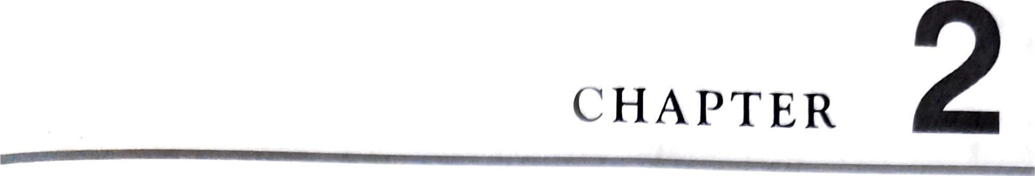
Diodes and
Applications
GOALS AND OBJECTIVES
 Discussion of various types of diodes
 Description of PN-junction diode
 Zener diode and its applications as voltage regulator
 Types of rectifiers—half wave, full wave and bridge rectifier
photodiode
 Rectifier with centre tapped (CT) transformer
 Different types of wave shaping
 Explanation of special purpose diodes—Schottky, barrier and
INTRODUCTION
A diode is a two-layer (PN-junction) device which facilitates conduction in one direction and stops conduction in the other direction. It has a wide range of applications like rectification (converting ac to dc), voltage regulation, protection against high voltage and wave shaping. Furthermore, there are special purpose diodes, e.g. Zener diode, light-emitting diode and several others.

(22
As slÄ0Nvn in Fig. 2.1 , the junction is fornnecl when thin layers of IL and N-type semiconductor, are joined together that results in following phenomenon immediately.
- The nnajovity holes fronn P-side diffuse into N-ßidc and vice versa.
- Reeotnbination of electrons and holes in a na region on both sides of the junction results in uncovered fixed positive ions on N-sicle and fixed negative ions on p-si(le This is the depletion region where no free electrons and holes are present.
- The electric field set up by the positive and negative ions prevents further flow electrons and holes.
- The electric field causes the movement of minority carriers in opposite direction provides a minority carrier drift current.
- In steady-state, there is no net •current flow across the junction.
The simplified diagram of an open-circuit PN-junction diode is drawn in Fig. 2.2 where i/ is a constant potential. The P-side terminal is called the anode and the N-side terminal is the cathode. The symbol of diode is shown in Fig. 2.3.
Depletion region


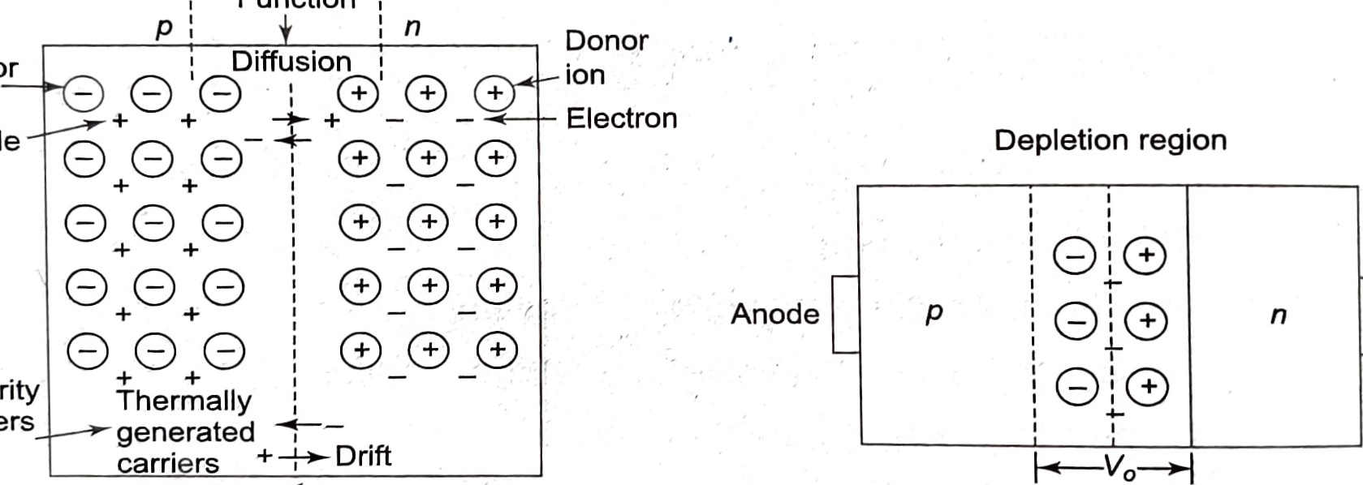
Function :
Acceptor
ion
Minority
carriers
Cathode
Fig. 2.1
Pig. 2.2
Phenomenon at PN-junctionAn open-circuited PN-junction diode

2.2.1 Reverse Bias
In reverse bias, the positive terminal of the battery is connected to N-side (cath^{ode}) ^{anc} negative terminal of the battery is connected to P-side (anode) as shown in Fig. 2.3•
As a result of reverse biasing, the majority of holes and electrons are pulled away ^{from} junction. This causes the width of the depletion region to increase. Therefore, th^{e} 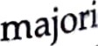carrier current cannot flow. However, the minority carrier drift current flows but s^{ta}y^{s at} saturation level Is as the minority carrier concentrations are very low. Is is known as the revers saturation current, which is almost of negligible order (nA for Si and LIA for Ge).

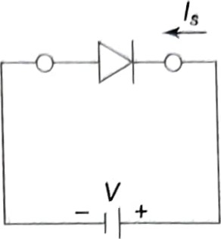
Depletion region widens
Anode Cathode
Fig. 2.3
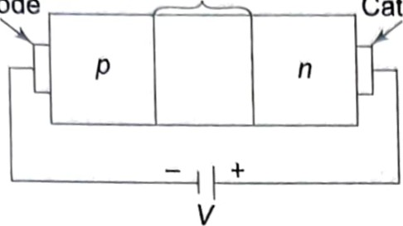 Symbol Reverse-biased diode
2.2.2 Forward Bias
The positive terminal of the battery is connected to the anode (P-side) and negative terminal, to cathode (N-side). The holes from P-side and electrons from N-side get pushed towards the junction, thereby narrowing the depletion region. As a result, holes easily cross to N-side and electrons to P-side constituting the injunction current (ID. The reverse saturation current Is flows in the opposite direction. The net forward current If = Ii — Is increases sharply and is limited to a value determined by an external series resistance (load).
Depletion region 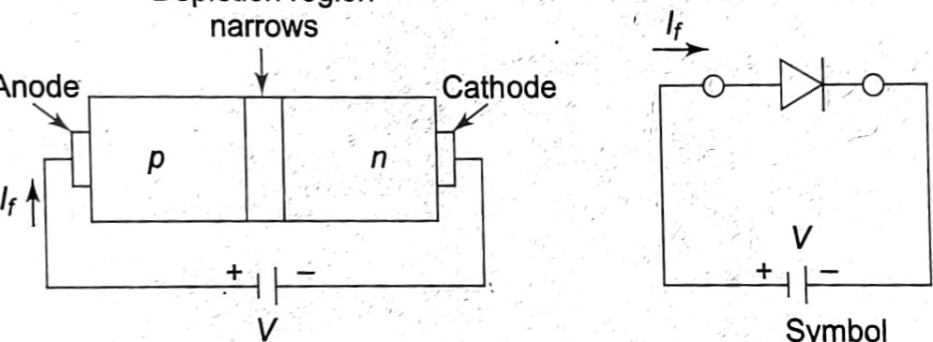narrows
Anode
Symbol
Pig. 2.4
Forward-biased diode
2.Derive the diode current equation and explain each term.
+ Diode Relationship
^{I}D = Is(ekVD/Tk — 1) (2.1)
where • Is = reverse saturation current k = 11,600/ n; = 1 for Ge and = 2 for Si kor low current, below the knee of the curve and
= 1 for both Ge and Si for higher level of current beyond the knee (see Fig. 2.5). Tk = Tc+ 273⁰, and
Tc = operating temperature (25⁰C)
The plots of Eq. (2.1) for Ge and Si diodes are drawn to scale in Fig. 2.5. The sharply rising part of the curve extended downward meets the VD axis, which is indicated as
VT = offset, threshold or firing potential,
It is quite accurate to assume that ID = 0 up to VT and then increases almost linearly at a sharp slope. The values of VT are
VT = 0.7 V for Si diode

VT = 0.3 V for Ge diode
ID(mA)
30  25  20  15  10  5  Is(Si) = 0.01 10 nA vz(Si) vz(Ge) |  |  | 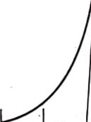 | Si  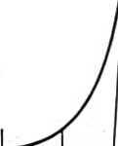
 | Si | 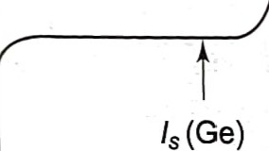 | 0.1 0.2 0.3 0.4 0.5 0.6 0.7 0.8VD(V)  1 PIA VT (Ge) VT (Si)

Diode characteristics
EXAMPLE 2.1
An Si diode has Is = 10 nA operating at 25⁰C. Calculate ID for a forward bias of 0.6 V.

Solution We take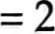
Tk - 25⁰ +273⁰ = 298 ⁰
11,600
= 5,800
2
5800 xo 6
k%/Tk = • = 11.68
298
11.68
= 117930
Then - 10 (117930 - 1) = 10 x 0.117929 x 106 nA
1.18 mA, negligible.
This justifies the choice of = 2
Note: The diode is to conduct current much larger than this value.
Therefore, ID 1.18 nnA may be approximated as zero,
Zener Region As the reverse-bias voltage is raised, the diode breaks down at voltage vz, by avalanche 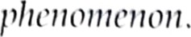 The nnaximum negative voltage that a diode can withstand is at Peak Inverse Voltage (PIV rating).
zenerBreakdown By heavily doping the N- and P-regions, the breakdown voltage vz can be brought as low as —10 V, —5 V. This mechanism of breakdown is different from avalanche. This type of diode is called zener diode. When connected at a point in an electronic circuit, it does not allow the potential there to exceed the diode rated voltage.
2.2.3 Equivalent Circuit of Diode
+ Ideal Diode
It conducts when VD > 0 as shown in Fig. 2.6(a).
+ Piecewise Linear Model
From the diode characteristic ofFig. 2.5, the piecewise linear characteristic follows and is drawn in Figs. 2.6(a), (b) and (c) along with its circuit model.
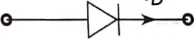
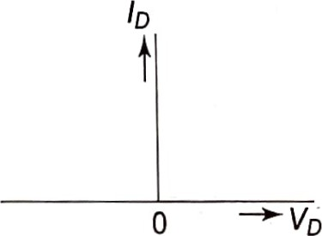 ID
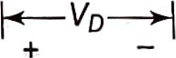
(a)
rd = dynamic resistance Ideal diode
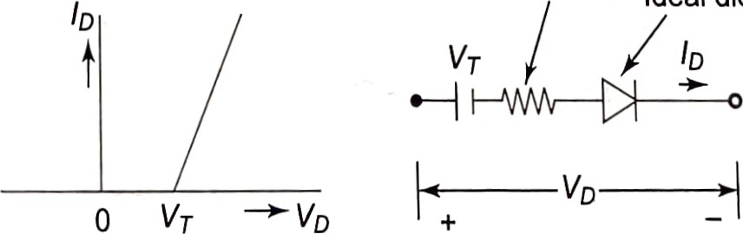
0
(b)
Ideal diode
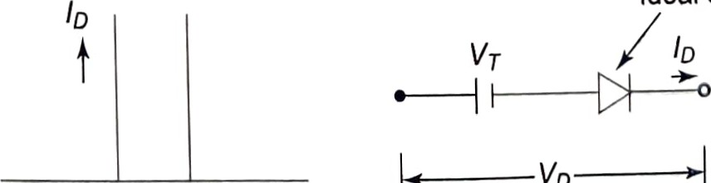
VD
0 VT —>VD
a) Ideal diode (b) Piecewise linear model (c) Approximate model

+ Dynamic Resistance
¯ (average)
rd
dlD
It can be proved that dynamic resistance on any point of the actual IV characteristic of diode is given by
26 mV
(2.2) ID (mA)
The dynamic resistance of rd is quite small and order of few ohms.
Approximate Model Assuming I'd = 0, the model characteristic and circuit are drawn in Fig. 2.6(c). This equivalent circuit of diode is used most often.
 For the diode circuits of Fig. 2.7, find the value of l. Use approximate model of the diode.
20 v
Si
Si
Si
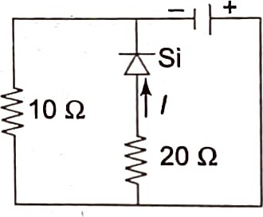
IOQ
10 v 10 Q
12 v
(a) (b)
Pig. 2.7

Solution
- The Si diode is reverse biased by 12 V. So it does not conduct.
- The voltage across diode branch is 20 V independent of 10 Q resistance. Therefore the diode conducts. As per equivalent circuit,
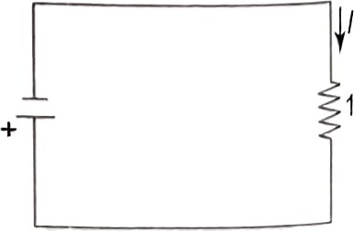
20-0.7 19.3
- 0.965 A
20 20
10 v100 (c) The two diodes are in opposition and cannot conduct (open circuit).
Thus,
(d)
10
Fig. 2.7(d)
1
10

 the diode citcuits of Cig R, determine and vo using Approximate model of Che diode
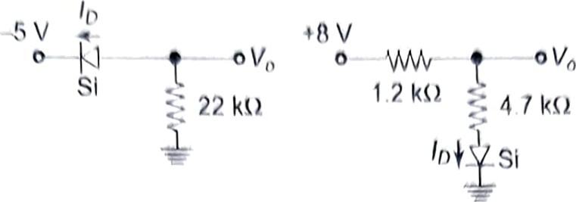
(a) (b)
Fig. 2.8
Solution (a) The equivalent circuit is drawn in adjoining Fig. 2.9(a).
Fig. 2.10
0.7 ^{I}D +8 V 1.2 kQ
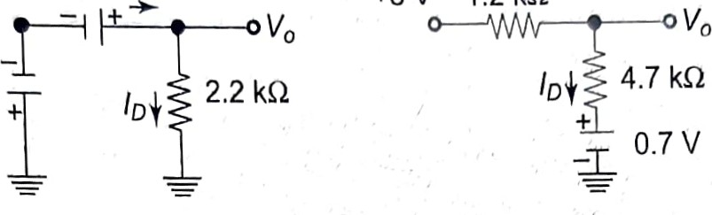

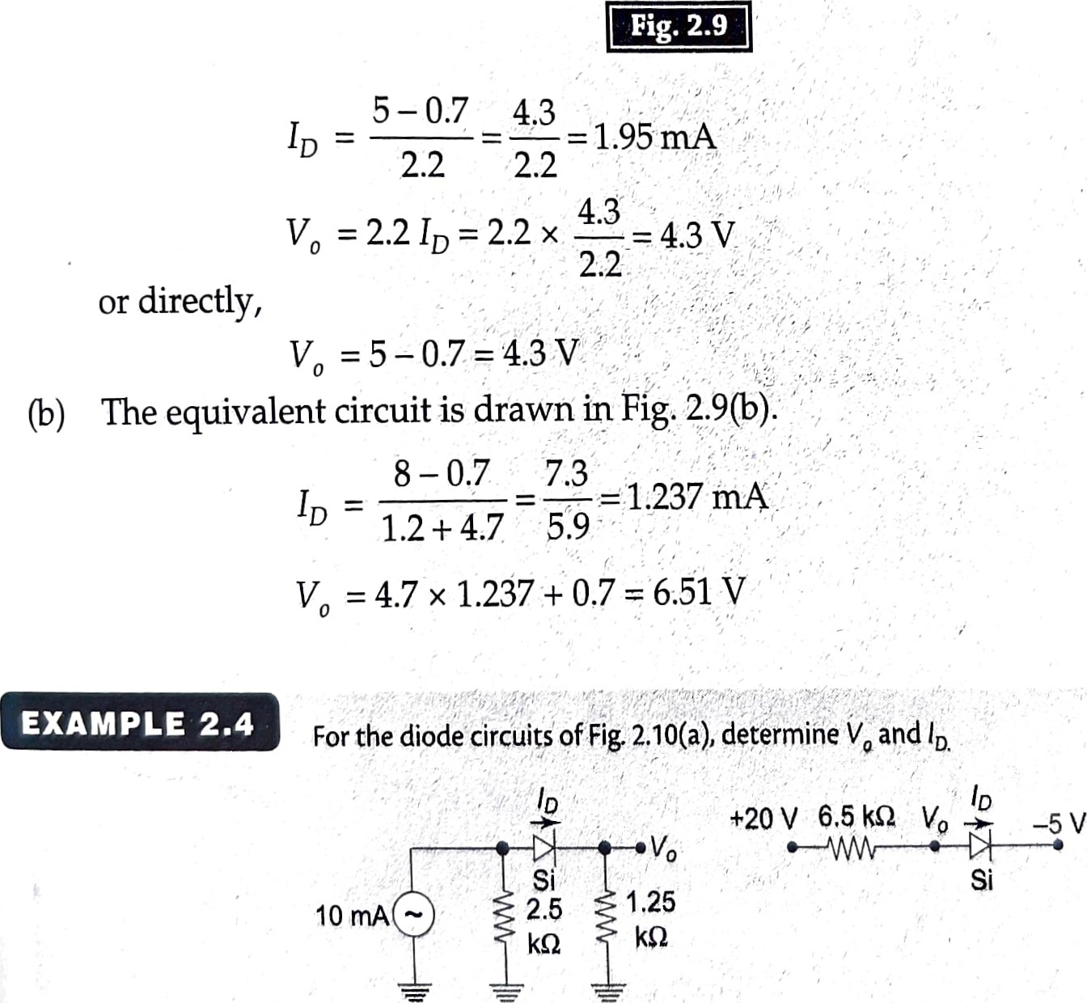vo
(a)
(b)
(b)

(a) Converting the current adjoining source figure to voltage (Fig. 2.11).source and diode by its 2.5 circuit kO model, we get th circuit of
+25 v
ID
25 07
= = 6.48 mA 1.25
2.5 + 1.25 vo = 1.25 x 6.48 = 8.1 v
Pig. 2.11
(In) We can proceed directly.

20-0.7+5
= 3.738 t-nA
6.5 vo = 20 - 3.738 x 6.5 = -4.3 v or Vo = -5 + 0.7 = -4.3 v
EXAMPLE 2.5
For the network of Fig. 2.12, determine Vol and V02
4.5 kQ
+12 V02
Si Vol
Fig. 2.12

Solution
V02 = 0.3 V or VT(Ge) = 0.3 V when conducting vol = 12-0.7 = 11.3 V
Note the result does not depend on 4.5 kQ.
EXAMPLE 2.6
For the diode network of Fig, 2,13, determine vo,
Si
+12
Il
Ge
Pig. 2.13
Solution Diode Ge conducts, holding voltage at VT = 0.3 V. Therefore, diode Si does conduct as its VT = 0.7 V

12 0 g
1
1
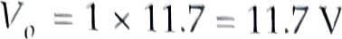
EXAMPLE 2.7
Deternnine Vo (or the negative logic OR gate.
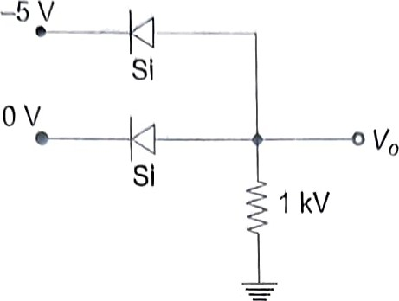
Pig, 2.146)
Solution Top diode conducts

vo --5+0.7=-4.3 v
Lower diode is negatively biased, so does not conduct.
The output will be Vo = —4.3 V (high of negative logic) for input —5 V at any one or both terminals. The output will be zero (low) if both inputs are zero. This is presented in tabular form in Fig. 2.14(b).
 |  | 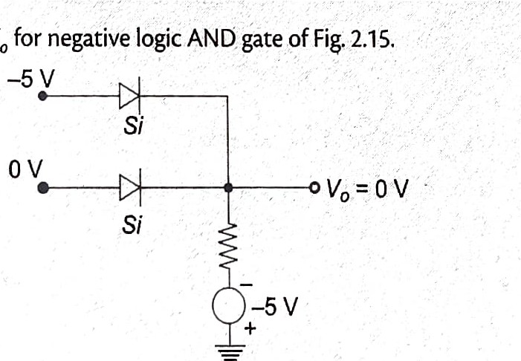  Determine  Vo
  _EXAMPLE 2.8
  Fig. 2.15
Solution The lower diode will conduct.
vo (low, 0)
In
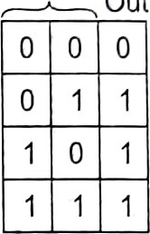
Out
O - Low (0 V)
1 - High (-4.3 V)
Fig. 2.14(b)

If both inputs are 0 V, both diodes conduct. Vo = 0 V (low, 0). If both inputs are —5 V, both diodes do not conduct, Vo = —5 V (high, 1).

Rosic flectmnics
high, low, ()
The tvsult is presented in the lable below.
In
out
nan
This is negative, AND.
ZENER DIODE
The A zener symbol diode of has the zener zener breakdown diode is drawn in reverse in bias Fig. as 2.16(b). shown Its in equivalent IV characteristieof circuit is Fig. drawn 2.16(a)in
Fig. 2.16(c). It is connected in a circuit such that it is reverse biased. It conducts only if reverse bias exceeds vz. For positive bias, it acts as short circuit.
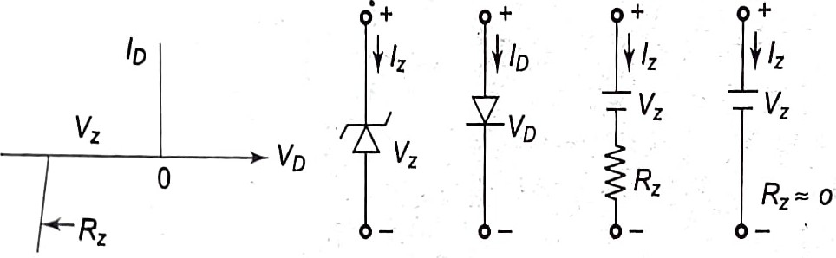
Zener diode Ordinary Zener diode
IV Characteristic Symbol diode equivalent circuit
Symbol
Fig. 2.16
Zener diode
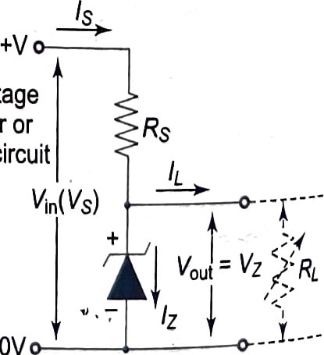
203.1 Zener Diode as a Voltage Regulator Voltage regulators are the devices used to maintain constant voltage across a load despite of fluctuations in the input voltage and load currents. The Zener dc input voltage diode in its reverée bias region is widely used as a from rectifier or voltage regulator as it continues to operate till the smoothing circuit magnitude of current becomes less than IZ(min). The typical Zener voltage regulator is shown in Fig. 2.17. The Zener diode of breakdown voltage Vz is connected to the input supply in reverse direction, For all the values of current within the breakdown region, the voltage across the diode will remain Zener diode as a voltage regulator fixed at 14, giving a constant supply across its load.
The resistance Rs controls the current flowing in the circuit.

Case I: When no load is connected (IL O)
The current t10M'ing in the circuit entirely passes through Zener diode. The diode dissipates maximum Thus, uttnost care must be taken while selecting the series resistor so as to maintain the pmver dissipation within the range of maximum power dissipating capability of the diode.
Case Il: When load resistance RL is connected across the diode
Here, since the load is parallel to Zener diode, the output voltage will be equal to Vz. The Zener current must always be above Iz(min) (current for which the stabilisation of voltage is effective). The higher limit of current allowed to flow in the circuit depends upon the power dissipating capability of the components used.
The voltage regulation can be done through two techniques:
- Line Regulation In this case, series resistance and load resistance are kept constant and it is assumed that all the variations in voltage arise due to fluctuations in input power supply. The regulated output voltage is achieved for input voltage above certain minimum level. The percentage of regulation is given by
x 100
where Vo is the output voltage, VIN is the input voltage, and AVO is the change in output voltage for a particular change in input voltage AVIN.
- Load Regulation In this, the input voltage is fixed while the load resistance is varied. The constant output voltage is obtained as long as the load resistance is maintained above a minimum value. The percentage of regulation is given by
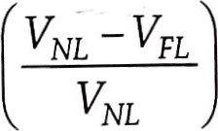x 100
NL
where VNL is the voltage across the Zener Diode when no load is applied and VNL is the full load resistor voltage.
EXAMPLE 2.9
The circuit of Fig. 2.18 has a zener diode connected across the load.
200 Q
v
20
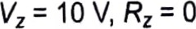
Pz(max) = 350 rnW
Fig. 2.18
2.12 Rosic Electronics
(a) RI 180 Q, determine all currents and voltages. (b) Repeat part (a) for RI 450 0.
  - Find the value of RI for the zener to draw maximum power.
  - Find the minimunn value of RI for the tener to be just in on-state,

Solution
(a) As RI is small, assume that the zener does not conduct,
i.e.
20
Then,= 52.6mA
200 + 180
-3 = 9.48 < 10 v vz 20 -200 x 52.6 x 10 So our assumption is correct.
RL = 450 Q
Assume that the zener conducts.
10 V
10 ³
—x 10 22.2mA
450
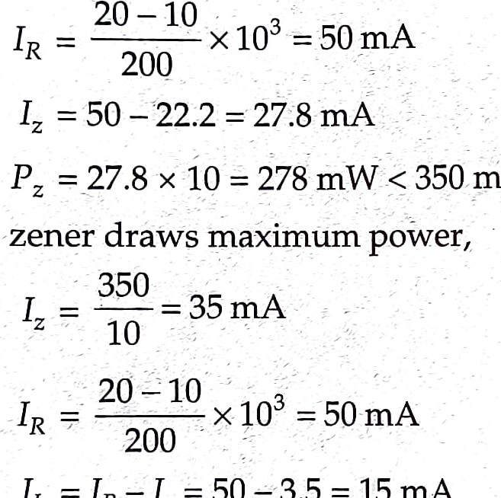
< 350 mw (rating)
50-3.5
=
15mA
- When the zener
Then
10
X 10-3 = 667 Q 15
- Iz — 0 (just on state)
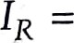50 mA = IL
10 v
10 -3
RL (min) 50 x 10 - 200 Q
)
EXAMPLE 2.10
Determine the range of Vi in which the zener diode of 219
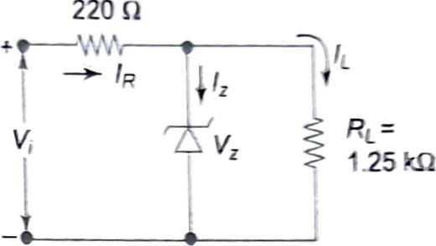
220
vz=20V,
1200 mW
Fig. 2.19

Solution
(a) V: just in conducting state
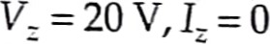
20
= 16 mA
1.25
20 + 220 x 16 x 10-3 = 23.52 v
1200
Iz = Iz(max) = = 60 mA
20
IL = 16 mA
IR = 60+16=76mA
20 + 220 X76 = 36.72 V
For input voltage from 23.52 V to 36.72 V, VL will remain constant at 20 V.
EXAMPLE 2.11
For network of 2-20, determine the range of RL < IL that will result in V.. being at 10 V. Also determine wattage rating of diode
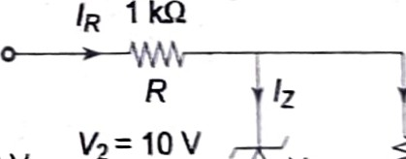¹/2 ² 10
= 32 rnA
Fig. 2.20
Solution Value of RL that will turn Zener diode on

RV2 1000x10
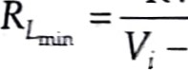
=250Q
50-10


\ aet•oss R, i.e.•10 40 v
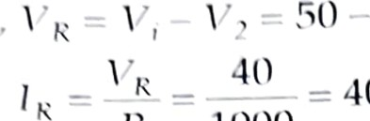
4() mA 11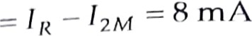
R 1000
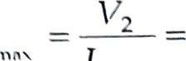
10
- 1.2 ICQ
12 8 mA
min
= 320 mVV max i 2M
2.4 | RECTIFICATION
The diode is an ideal and simple device to convert ac to dc. The process is called
We shall focus our attention on some performance measures of a rectifier: dc Voltage, rippl

2.4. I Half-wave Rectification (Sinusoidal Input)
The half-wave rectification is carried out by the simple circuit of Fig. 2.21 with a single The diode conducts during positive half-cycles of input voltage and cuts off during half-cycle. The input and output waveforms are shown in the Fig. 2.21.
The dc output voltage can be expressed as
dc 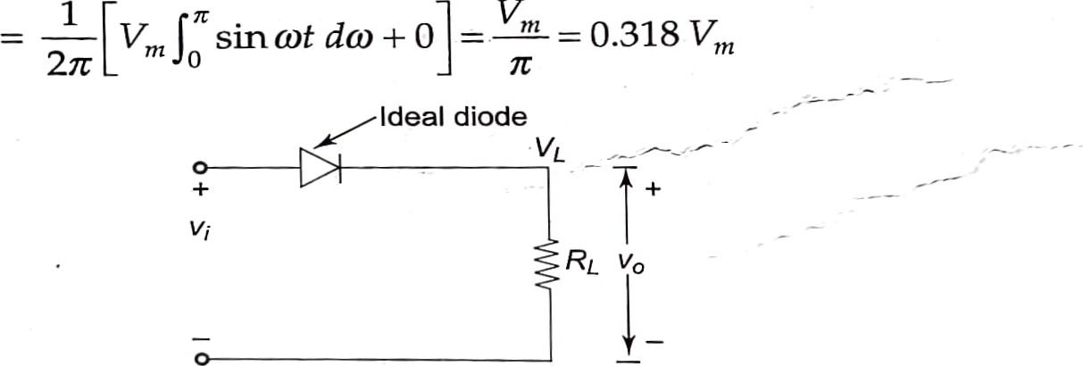 (2.3
(a)
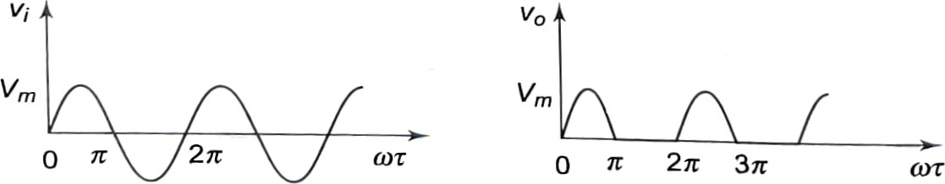TC 27t
(b) Input voltage wave (c) Output voltage wave sinusoidal
Fig. 2.21
Input/output waveforms of half-wave rectification
vrn 1
Then Idc -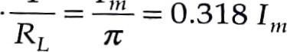
PIV—During negative half, the input voltage reverse biases the diode. So PIV = vm

Diodes and Applications 2.15
Ripple Factor
Ripple is the variation of output voltage about dc, which is quite large in a half-rectified wave.
It has a times ftvquency to the frequency of the input voltage.
Ripple factor is defined as rms value of the ac connponent of load (output) voltage
(2.5) dc component of load voltage
We can write the equality
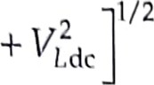
¯
L rms acrms
l,
1/2
or 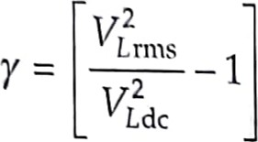 (2.6)
L rms ¯— rms of half sine wave (0 — It) over (0 - 270
2 | ⁷2
L rms ¯
= 2
1/21/2
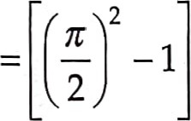
(vnt /2Y
Then -1-1.21 (2.7) (vm/ny
We find that ripple factor of a half-wave rectifier is quite high, which is unacceptable.
The value of vdc can be adjusted by providing Vi from a transformer of appropriate turn
ratio.
For small values of V111 we need to replace vm by (Vm — VT) in all the above relationships.

+ Power Conversion Efficiency
It is defined as dc power output ac power input
Assuming the diode to be ideal in a half-wave rectifier, dc output = Idc RL ac input = 1rms² RL
1 | 2
rms2
2 2 2
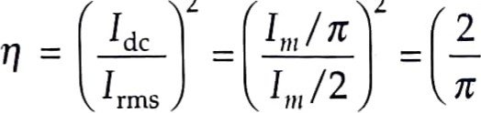 — 0.405 or 40.5% (ideal) (2.8)

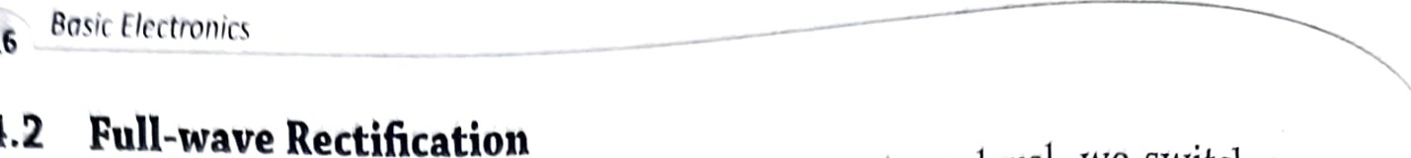
In order to the ripple factor and raise the dc voltage level, we switch to fulls 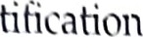in which the phase of the second half of the wave is reversed. The full, rectified waveform is drawn in Fig. 2.22.
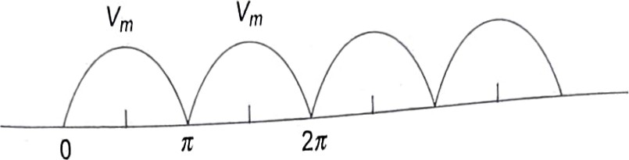
Fig. 2.22
Full-wave rectified waveform
Obviously,
—L = 0.637 (double of half-wave)
+ Ripple Factor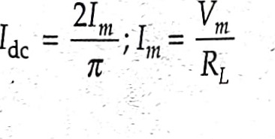
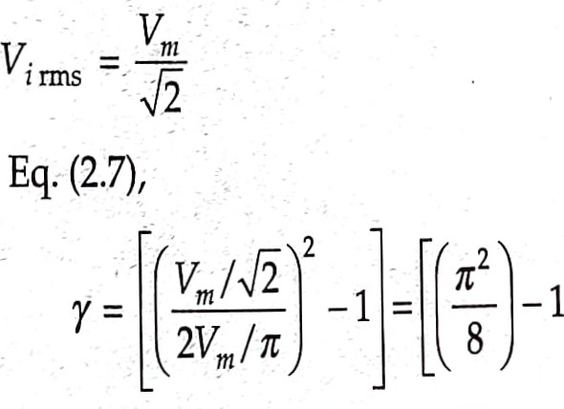
Substituting in Eq. (2.7),
1/2
= 0.482
(2.10!
The ripple factor is reduced from 1.21 to 0.482.
+ Power Conversion Efficiency
dc output = Idc RL
1
ac input = 1²rms RL
2 2
21m/lt 2Uä
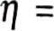 1 1m/0ä = Tt = 0.81 or 81% (ideal) (2
We shall now take up two full-wave rectification circuits.
2.4.3 Bridge Rectifier
It is a bridge of four diodes as shown in Fig. 2.23. In positive half-cycle of input Vi, did and D3 conduct through the load RL. The conduction path is shown by a solid line•

